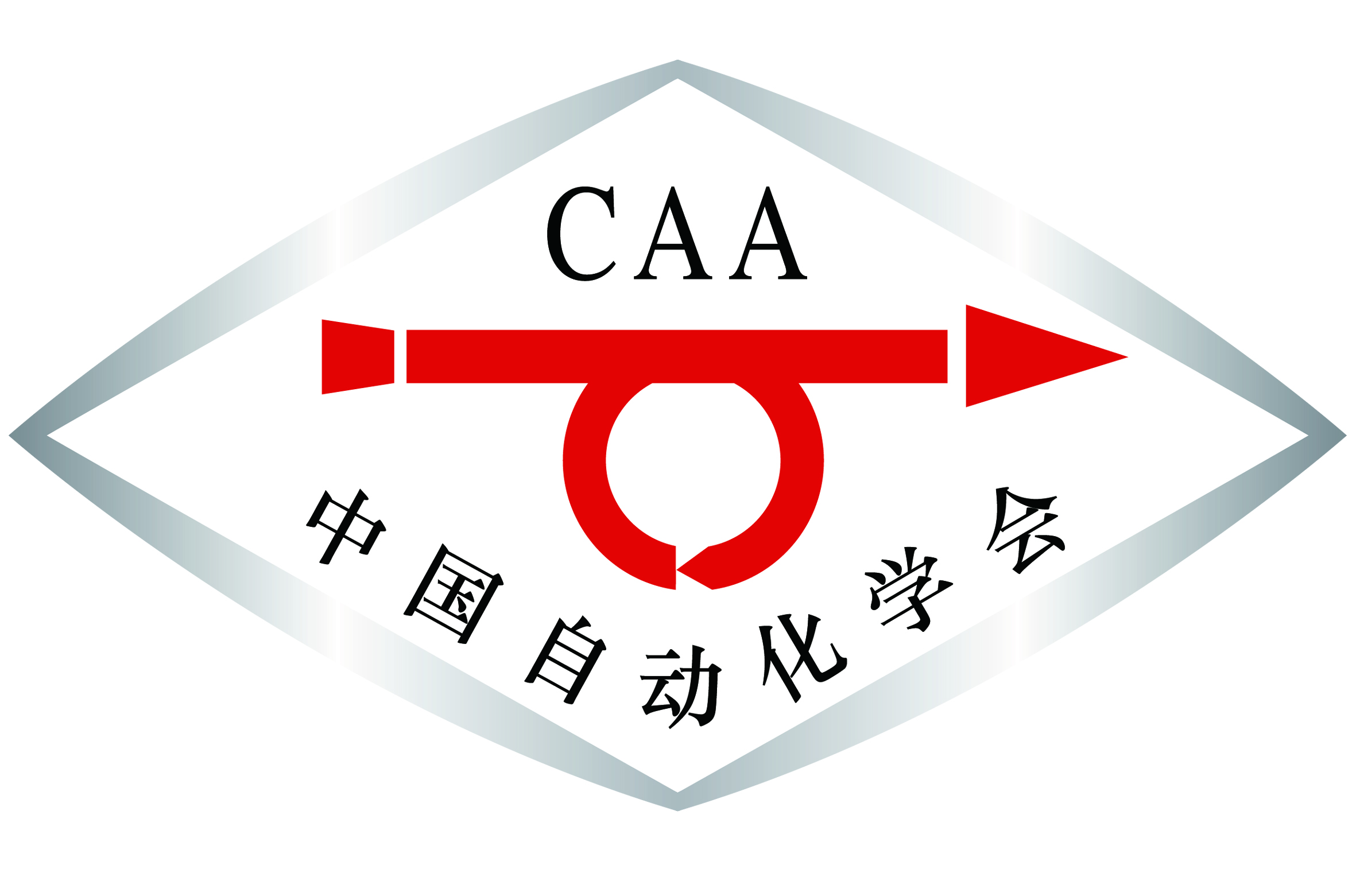

The 2018 IEEE Intelligent Vehicles Symposium (IV'18)
Changshu, Jiangsu, China
June 26 - July 1, 2018

IV’18 Workshop Proposal

- Title of the Workshop:

- Content and List of Topics:

- Organizers (names, affiliations, and emails):

- Potential Contributing Authors (titles, names, affiliations and emails):

